Piushan Wickramasinghe | G21319532

Development Log

Week 1: December 2-8, 2025
Date | - 05 December 2025
Time Spent | - 4 hours
Tasks Completed | - Prepared the needed development environment on the machine.  - Created a new flutter project.  - Made the necessary file structure.  - Researched on navigation bar implementation.  - Did some more research on API documentation.  - Signed up for API Key.
Challenges Encountered | - Confusion about the correct file structure of a flutter project.
Solutions | - Made a folder structure that beginner friendly.  - Reviewed few flutter documentations.
Reflection | Firstly, I learned proper project management will be helpful in the long run of the app. And initial setup process was very helpful to get a understanding about the project.
Next Steps | - Turning low-fidelity wireframes into actual flutter widgets.  - Making a simple welcome page.  - Reviewing HCI principle.  - Begin to create theme mode support configuration file for the app.

Week 2: December 9-15, 2025
Date | - 12 December 2025
Time Spent | - 5 hours
Tasks Completed | - Made a welcome page while following the low fidelity wireframe design with a logo placeholder.  - Added theme toggle functionality.  - Created a dart file for themes.  - Applied material design guidelines.
Challenges Encountered | - Making the app consistent across multiple platforms.  - Understanding color schemes so that I can implement color switching while maintaining the readability of the user.
Solutions | - Got referencing from google material design.  - About how to properly implement theme toggling.  - Maintaining a user-friendly color palette.
Reflection | I learned that material design guidelines provide very good standards for spacing and sizing. I was able to improve my UI design skills through that. My low fidelity wireframes allowed me to focus on implementing rather than designing part which made this process time saving. Also, I learned it is better to implement both themes at once rather than implementing at different times.
Next Steps | - Creating the rest of the pages and putting the place holders where it’s necessary.  - Researching the options for local storage.  - Setting up the packages for API Integration.

Week 3: December 16-22, 2025
Date | - 19 December 2025
Time Spent | - 4 hours
Tasks Completed | - Made the home page and implemented the loading indicators.  - Created a dart file to handle the API calls with proper error handling and implemented the API to homepage according to the wireframe design.  - Pull-to-Refresh functionality was added to the homepage.  - Was able to add the date and title to display from the API response.
Challenges Encountered | - Had to deal with rate limiting on the demo_key we get in the API.  - Understanding the manual state management with setState.  - Managing to display the API image with proper loading with error handling.  - Working with asynchronous API calls.
Solutions | - Added print statements to debug the API responses and track rate limiting issues.  - Decided to use setState to manage the loading states of the app to get more control over UI.  - Signed up for personal NASA API key to increase rate limits.
Reflection | I learned that API documentation is crucial and should thoroughly review before implementation. Through working with real API data allowed me to gained practical knowledge about asynchronous programming while also allowing me to handle various network states like loading , success , error.
Next Steps | - Creating another dart file to allowing to show quotes from a local text file.  - Putting random quote selection and putting a refresh button to interact with the user.  - Analyze path provide package for local file storage.

Week 4: December 23-29, 2025
Date | - 27 December 2025
Time Spent | - 3 hours
Tasks Completed | - Created the file that contains quotes.  - Implemented the quote dart file to load random quotes from the file. Using the dart’s random class.  - Updated the pubspec.yaml file to include the quote file.  - Integrated the quote display section on home page just as the low fidelity wireframes.
Challenges Encountered | - Needed to know how to parse and properly load text files from the assets.  - Had to decide the format for the quote file.
Solutions | - Used rootBundle.loadString() to read text file from assets.  - To store parsed quotes in memory after first load I implemented caching mechanism.  - Added error handling for file loading failure.
Reflection | As HCI principles mentions efficiency is one of the key factors of a good program which is why users shouldn’t experience delays when interacting with quotes. For that the catching pattern prevents unnecessary file reads and improves performance. And the quote refresh button adds an element of user control that enhances engagement.
Next Steps | - Design a logo for the app  - Making the next page.  - Creating a new dart file for managing the saved items.  - Updating the home page with favorites button.

Week 5: December 30, 2025 - January 5, 2026
Date | - 02 January 2026
Time Spent | - 4 hours
Tasks Completed | - Completely designed a logo for the app.  - Created variations of the logo.  - Used modern font to design the wording.  - Added the logo to the asset in the project.  - Integrated the logo to the welcome page.
Challenges Encountered | - Learning the few new tools for the first time Photoshop.  - Balancing the details with the scalability.  - Choosing matching color scheme that blends with the existing color scheme.
Solutions | - YouTube Tutorials helped me to overcome the complexity faced when using new tools.  - Researched about color schemes online to get a good knowledge of the color theories.  - To overcome the quality loss, exported the logo in a high quality and then scaled down.  - Added the logo to welcome page and planed to include the logo in the about page as well to keep the brand consistency.
Reflection | Was able to learn more about the fundamentals of graphics designing like composition, color theories and most importantly visual hierarchy. Adding the logo to the most important parts of the app allowed me to understand the aesthetic design and brand consistency in HCI Principles. The rocket theme perfectly tells a user about the space exploration concept of ORBIX.
Next Steps | - Making the changes to favorite service dart to implement functions like add remove and get.  - Making the add to favorite buttons functional in the home screen.

Week 6: January 6-12, 2026
Date | - 09 January 2026
Time Spent | - 6 hours
Tasks Completed | - Put path provider package for accessing device file system.  - JSON Serialization used for saving favorites to the file.  - Updated the home page with toggle favourite button.  - Added addFavorite(), removeFavorite(), getFavorites(), and isFavorite() methods.  - Created fromApodData factory method to convert API data to favorites.  - Added visual feedback.
Challenges Encountered | - Learning JSON serialization in dart.  - Learning about flutter’s file system access and permissions.  - Handling asynchronous file operations.  - Updating the UI state accordingly.
Solutions | - In the terminal I ran ‘Flutter clean’ and rebuilt the project to solve plugin issues.  - For detailed error logging I used to try – catch blocks.  - To prevent multiple copies before saving the files I added duplicate checking.
Reflection | I added immediate visual confirmation through heart icon animation and mainly focused on persistent data storage.
Next Steps | - Implementing the favorites page with grid layout.  - Implementing the remove favorite functionality.  - Detailed view for the favorite’s tiles.

Week 7: January 13-19, 2026
Date | - 16 January 2026
Time Spent | - 5 hours
Tasks Completed | - When there are no favorites in the tab It shows a message.  - Pull to refresh on functionality on favorite page.  - Loaded favorite from the storage.  - Added a dialogue box when removing from the favorite.  - Added a counter to the page header.
Challenges Encountered | - Learning the grid view layout.  - After removing an item tab should update immediately.
Solutions | - Implemented image catching through Image. network default behavior.  - For consistent behavior I changed navigation from push/pop to push replacement.  - For pull to refresh functionality I implemented the Refresh Indicator.
Reflection | Error prevention and protective users from accidental actions , I was able to handle those by adding a confirmation dialog before removing favorite from the tab. And as a sense of control I was able implement Pull to refresh feature because it has become an natural gesture in most mobile apps.
Next Steps | - Implementing the history page with date picker functionality.  - Implementing a functionality to add to favorites from the history.  - Creating history tile page with API integration.

Week 8: January 20-26, 2026
Date | - 23 January 2026
Time Spent | - 6 hours
Tasks Completed | - Implemented date picker widget to the history page with the in-built flutter functionality.  - Updated apod_service.dart with fetchApodByDate() method  - Date ranges restrictions are set according to the API.  - Add to favorite option added to the history page as well.  - Loading states and error handlings were added for error handling.
Challenges Encountered | - Correct format to calling API for date parameters.  - Making sure the add to favorite function works correctly in the history page.
Solutions | - Reused the same functionality from the home page for add to favorite functionality.  - Added error messeges to prevent the users from inputting invalid dates.  - Added date parameters to the date picker.
Reflection | The ability to view older images made this app more valuable since users will able to revisit the past astronomy pics of interest.
Next Steps | - Put the logo on the welcome page  - Adding the space facts  - Putting app information on About page after implementing the page  - Finalizing the navigation  - Testing the user flow

Week 9: January 27 - February 2, 2026
Date | - 30 January 2026
Time Spent | - 4 hours
Tasks Completed | - Tagline updated to the ‘Explore the Cosmos.  - Made sure the about screen has the same design as the other screens.  - Created 4 educational facts in the space fact session in card format.  - Completed the about page with according to wireframes.
Challenges Encountered | - Including only, he needed information about the app.  - Making sure that the logo displays correctly in dark and light theme.  - Keeping the about [age informative and also visually interesting.
Solutions | - Used visual hierarchy so that the user won’t be confused.  - Tested the visibility of the logo in both theme environments.  - As in the other pages used card-based design to keep the information organized.
Reflection | Even though the about page is often get overlooked by the users, I realized that this page is carries most of the brand identity and most important for the user trust. And also according to the HCI principles, users should be able to find information about the app easily.
Next Steps | - If there are bugs, they need to be fixed.  - Overall testing across all screens.

Week 10: February 3-9, 2026
Date | - 06 February 2026
Time Spent | - 5 hours
Tasks Completed | - Fixes Spacing and Alignments  - Improves error messages.  - Tested the theme functionality  - Tested the application on both emulator and physical device.  - Tested few edge cases.  - Tries add few tests cases. (Unit & Widget testing.)
Challenges Encountered | - Finding all the edge cases.  - Finding all the alignment issues.
Solutions | - Created a testing checklist.
Reflection | I learned about quality assurance in this week mainly. And also realize that the developers can’t assume ideal conditions every time when testing in real-world.
Next Steps | - Writing the evaluation report.  - Getting ready with final presentation and demonstration.  - Reviewing all documents.  - Completing the development logs and rechecking it.

Week 11: February 10-16, 2026
Date | - 13 February 2026
Time Spent | - 5 hours
Tasks Completed | - Did heuristic evaluation  - Compared wireframes to the final design for evaluation.  - Added the reference list.  - Screen short preparation.
Challenges Encountered | - Structured the evaluation logically.  - Looked for both strengths and weaknesses.
Solutions | - Created comparison images.  - Reviewed each screen systematically noting strengths and issues
Reflection | Making a development log became a kind of a valuable record to my learning journey since it shows my progress from a simple idea to a working application.
Next Steps | - Practicing demonstration presentation.  - Submitting the documents before the deadline

Evaluation Document

Wireframes vs Final build Analysis
Even though I made some enhancements to the final build of the wireframes, the final build evolved significantly from the low fidelity wireframes. The enhancements were made to improve user experience and the functionality of the ORBIX application.

1.Welcome page
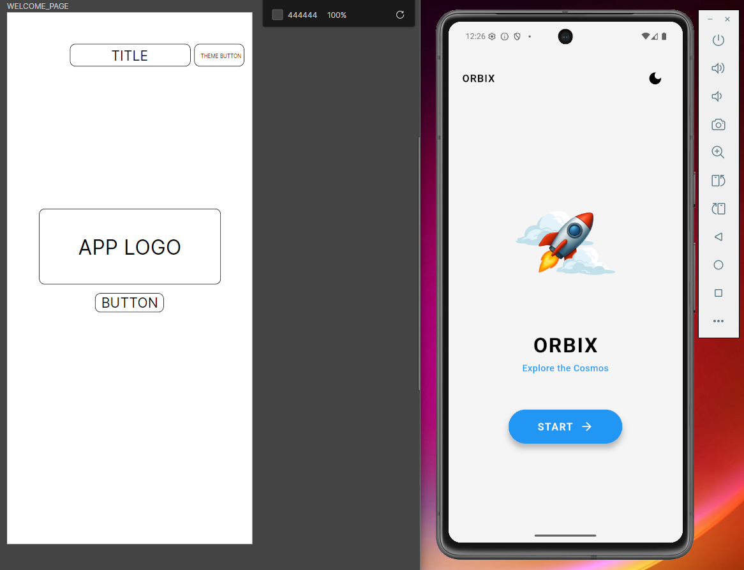

To improve the brand identity and visual appeal I have put the app logo in the centre or in the app logo placeholder like in the wireframe.And also I included the tagline of the app. Basically the main layout was involved from the wireframe as you can clearly see in the above image. I have move the title / app name to the left side to keep the balance in the screen elements. Instead of a button I have put a small icon to change the theme.

2.Home page
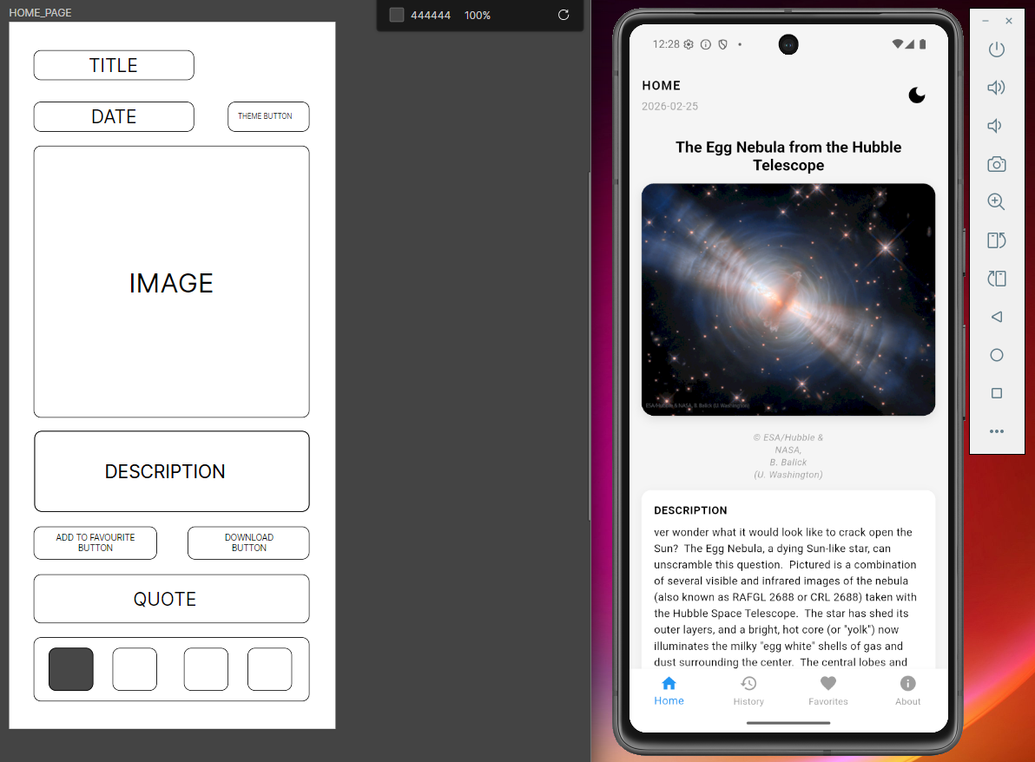

Did change some elements on this page to include more information as this as the most important page of the app. First, as you can see, I have added the title of the image on the top of the picture that is not there on the wireframe and after the description part there is quote section which I have implemented but can’t see the full screen on the image. For that quote part I have added a small logo on that tile to change the quote, by that user will be able to interact more with the app. And also, the two buttons are also there to providing the download and add to favorite functions. Additionally added error handling and loading indicators to appear during API calls.

3.History page
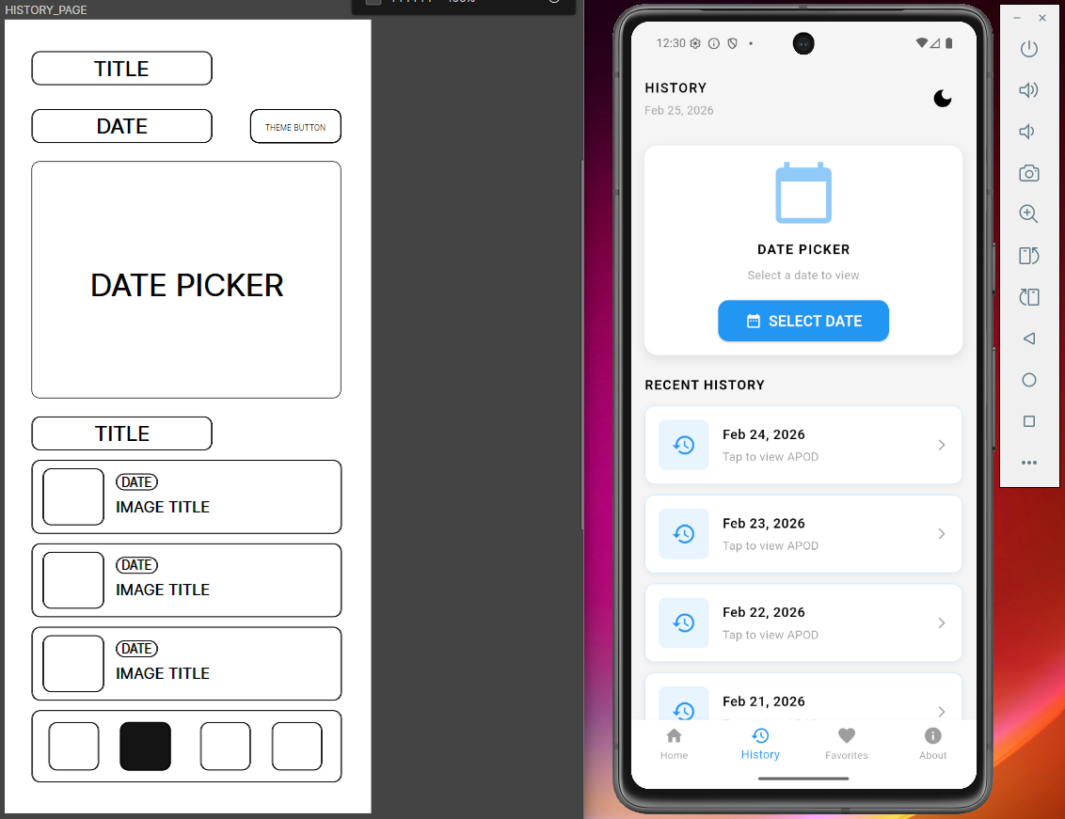

As you can see there are no changes happened to the history page because I didn’t wanted to make the user experience complex , So I kept it minimal and close to the design layout on the wireframe. Used the Date picker Widge from the Flutter’s library to implement the date select functionality.

4.Favorite page
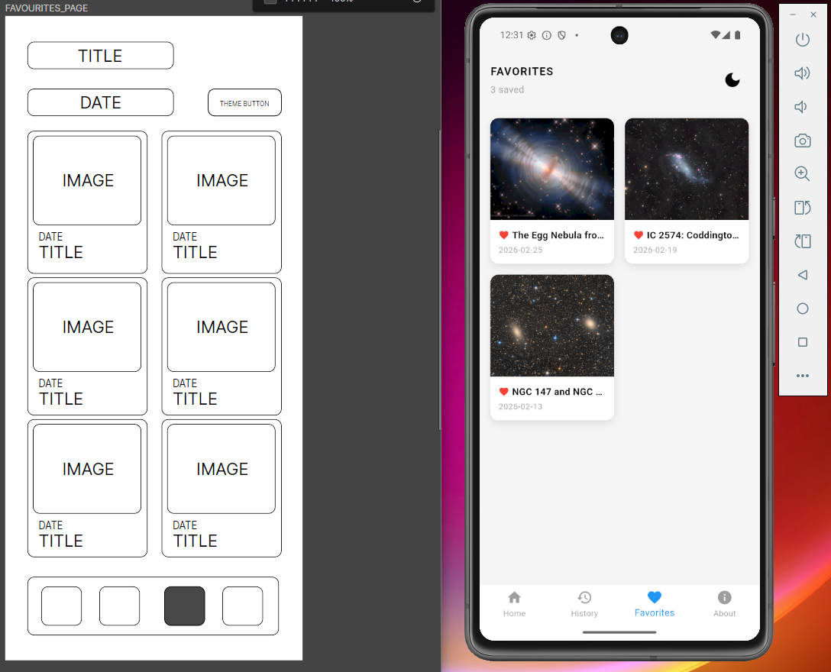

Same as the previous screen nothing has changes except for the dynamic counter that II have added to see how many pictures that a use has added to the favorites page. This will provide the user immediate feedback on collection size. Additionally in the detailed view added the option to remove the favorite functionality.

5.About page
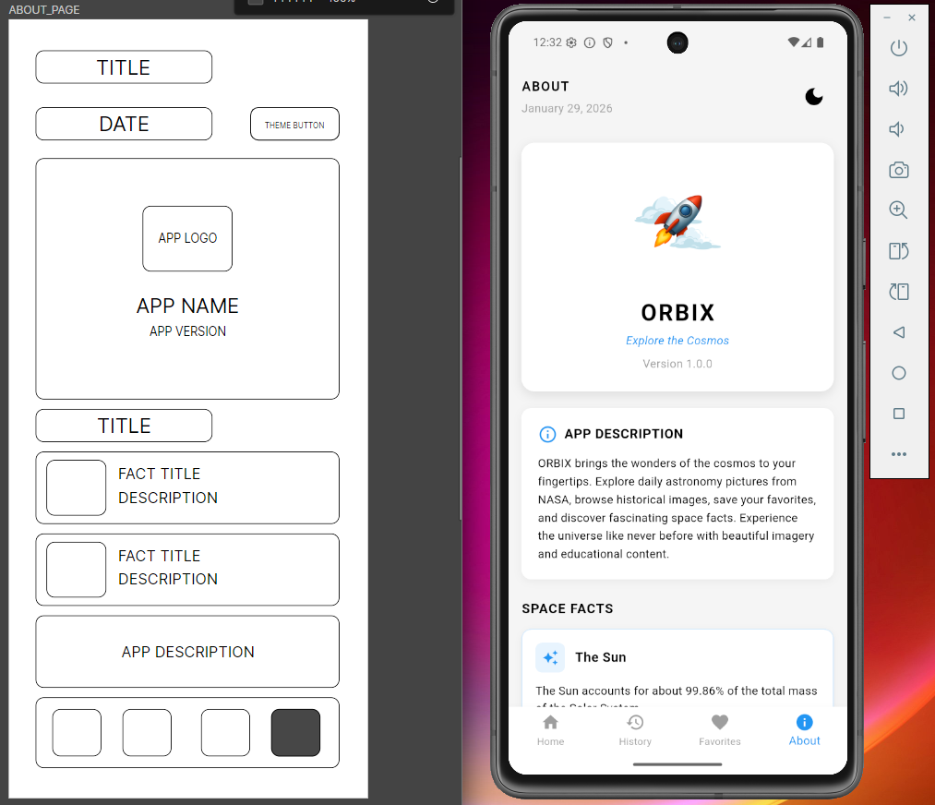

I did change the arrangement of the final design but kept most of the things in the same place, additionally I put the logo in the place holder for brand consistency. And then a short description about the app after that few random facts that’s put in to the code.

Heuristic Evaluation Using Nielsen's 10 Heuristics

1.Visibility of System Status
Strengths
- Pull to refresh function gives the user visual feedback with circular progress indicator.
- To indicate whether an image is already added or not the favorite button’s states get change accordingly.
- To inform users about the current states of the system operations, application provides clear loading indicators when fetching data from API. (Nielsen, 1990)
Issues
- No indication when the app is operating on a offline mode.
- Even though clicking the download button shows a snackbar message it doesn’t show the progress for larger images.

2.Match between System and the real world
Strengths
- Using the constant typography across the screens.
- Gave author attribution when using quotations in the quote section.
- Followed the conventional standards when putting dates.
Issues
- Errors like API rate limit could appear in error messages without and explanation this would confuse the user.

3.User control and freedom
Strengths
- Users have freedom to reload the page by pull-to-refresh function.
- Users have freedom to change their theme from any page of the app.
- Bottom navigation bar allows to switch pages at any moment of the app.
- On detailed pages there’s a back button for easy navigation. (Google, 2014)
Issues
- There’s no way to remove all the favorites at once.
- There’s no undo functionality in the favorites section when a user removes a favorite.

4.Consistency and standards
Strengths
- Bottom navigation bar remains consistent at the bottom of all pages. (Google, 2014)
- The layout of the top bar also remains consistent across all screens.
- Followed the Card-based layout throughout the screens.
- Used primary blue color for actions and red for destructive actions, and used grey for secondary info.
- Visual feedback for interactive buttons.
Issues
- The welcome page has a different layout than the others.
- Ther are various icon sixes in some positions.

5.Error Prevention
Strengths
- Restricted the date selection to a specific range given by the APOD range.
- Rather than creating duplicates in the favorite section the Add to favorite button shows a already in favorite message when a user tries to add the same image to the favorites.
- When user goes to remove a favorite program shows a confirmation message to prevent user from accidental deletions.
Issues
- The lack of error warning when a user attempts to download an image without storage permissions.

6.Recongnition rather than recall
Strengths
- For text clarity and icon recognition Navigation icons are labelled with texts as well.
- The current page gets highlighted in the navigation bar, so it’s easier for user to know where they are.
- Favorites are displayed as a visual grid so it’s easier for user remember the image visually rather than recognizing by the dates.
Issues
- There’s no search functionality for the favorites page.
- There’s no visual cue to let the users know that there is a function to pull – to – refresh.

7.Flexibility and Efficiency of use
Strengths
- The shortcuts on the history page provides quick access to previous days without using the date picker each time.
- Theme toggle adds flexibility and quick access to the user because, user doesn’t need to navigate to a different menu to change themes.
- For power users Pull-to-Refresh gesture serves as am efficient route.
Issues
- Not having a way to save multiple files at once to the favorite tab.
- No swipe gesture to navigate between screens.
- Not having advanced gestures for efficiency.

8.Aesthetic and minimalistic design
Strengths
- There are no unnecessary animations that could be distract from the needed information
- The custom-tailored logo adds a unique professional look to the app,
- The use if typography hierarchy guides attention to needed parts to first.
- For visual grouping and not to overwhelm the users with information I have used the card-based design.
- Clear minimal layout with white spaces improves the readability.
Issues
- The about page have multiple information that could overwhelm the users a bit.

9. Help Users Recognize, Diagnose, and Recover from Errors
Strengths
- Users won’t be confused when the loading state shows a spinner.
- User friendly error messages like ‘Failed to load today image. Please check your connection’ will be easier for user to recover from errors.
Issues
- There’s no explanation offline mode for explanation when the API is unreachable.
- Even though it shows error when downloads get failed it doesn’t tell the user how to resolve the error.

10.Help and Documentation
Strengths
- Clear labeling in all screens will reduces the needs for extra help.
- The app information, version number and small description about the app is provided in the about page.
- Facts section in the app provides concepts of astronomy and it will add value beyond core the functionality.
Issues
- Not having a FAQ section.
- Contact information or a link for the contacts to contact the user when an issue evolves.
- No tutorials

Conclusion
In conclusion I think this app thought me to how to implement a single idea into a fully functional application. Also, the necessary documentation process that a developer needs to create along the way. Overall, I see this app as a good app even though if I could implement features like an offline mode, improve the helping documentations and finally by adding some more advanced gesture features, I believe this application evolve to an excellent product level.

References
- Google (2023). Material Design. [online] Material Design. Available at: https://m3.material.io/. [Accessed on february 4 2026]
- Nielsen, J. and Molich, R., 1990, March. Heuristic evaluation of user interfaces. In Proceedings of the SIGCHI conference on Human factors in computing systems (pp. 249-256).
- Apple Inc., 2024. Human Interface Guidelines. [online] Available at: https://developer.apple.com/design/human-interface-guidelines/ [Accessed 15 January 2026].
- Flutter Dev Team, 2024. Flutter Documentation. [online] Available at: https://docs.flutter.dev/ [Accessed 5 December 2025].

